Hotel Revenue Analysis

**Objective:**  
To analyze hotel booking data using SQL and Power BI in order to:

1. Evaluate whether hotel revenue is growing year over year.
2. Assess if parking lot size should be increased based on guest demand.
3. Identify seasonal trends in bookings and revenue.

**Process:**

1. **Importing database into the SQL server management studio**

**Database name:** Projects

**Tables:** dbo.`2018$’, dbo.`2019$’, dbo.`2020$’, dbo.`market_segement$’ , dbo.`meal_cost$’

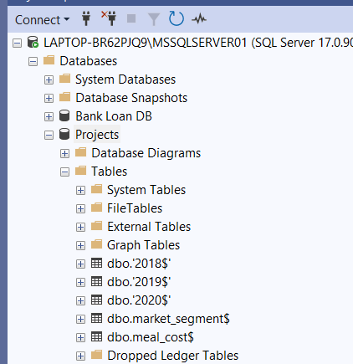

**EDA Queries:**

**1)Combining 2018,2019 and 2020 data**

**Before combining:**

select * from dbo.['2018$']

select * from dbo.['2019$']

select * from dbo.['

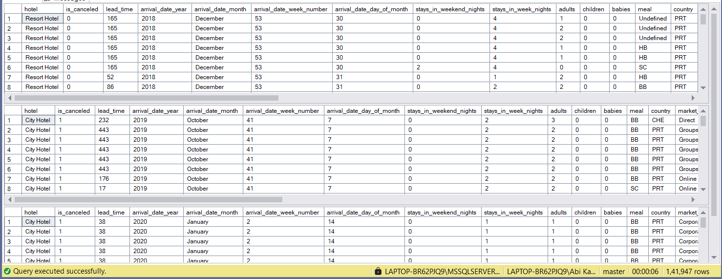

**After combining:**

with hotels as(

select * from dbo.['2018$']

union

select * from dbo.['2019$']

union

select * from dbo.['2020$'])

select * from hotels

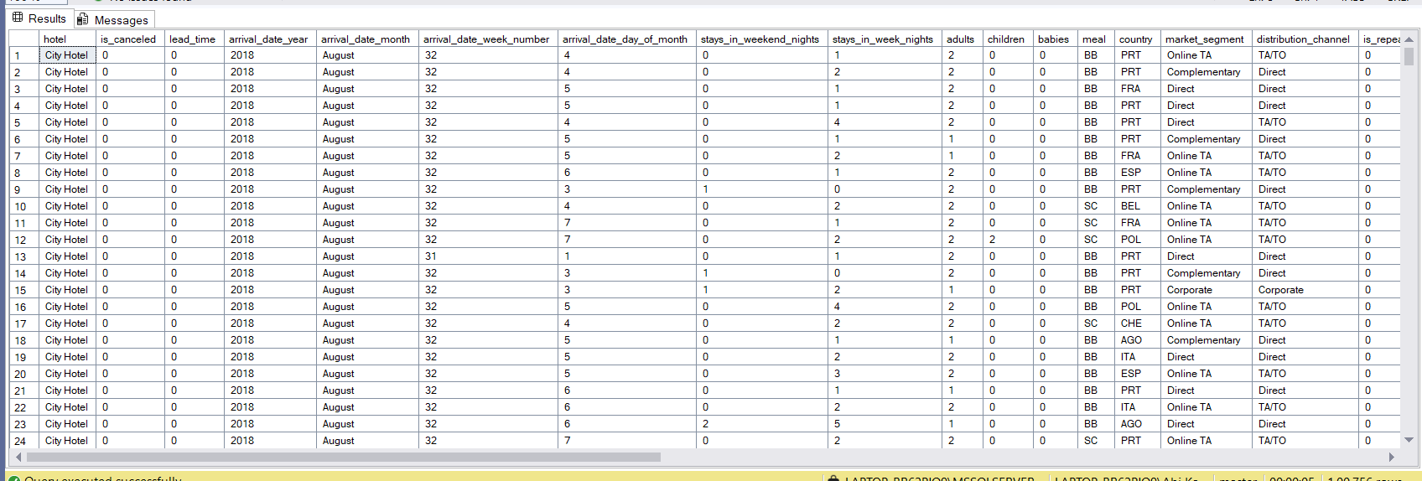

**Q.1: Is our hotel revenue growing yearly?**

select

(stays_in_week_nights + stays_in_weekend_nights) * adr as revenue

from hotels;

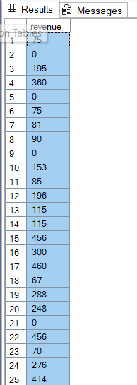

**By revenue year:**

select

arrival_date_year,

sum((stays_in_week_nights + stays_in_weekend_nights) * adr) as revenue

from hotels

group by arrival_date_year

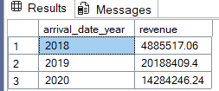

**By hotel name:**

select

arrival_date_year, hotel,

sum((stays_in_week_nights + stays_in_weekend_nights) * adr) as revenue

from hotels

group by arrival_date_year, hotel

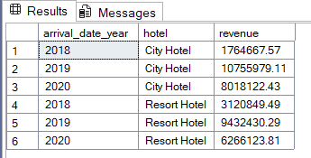

**Q.2: Should we increase our parking lot size?**

select

arrival_date_year, hotel,

sum((stays_in_week_nights + stays_in_weekend_nights) * adr) as renenue,

concat (round((sum(required_car_parking_spaces)/sum(stays_in_week_nights +

stays_in_weekend_nights)) * 100, 2), '%') as parking_percentage

from hotels group by arrival_date_year, hotel

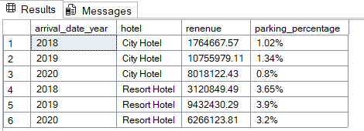

**## Connect to Power BI through this query for further analysis:**

with hotels as(

select * from dbo.['2018$']

union

select * from dbo.['2019$']

union

select * from dbo.['2020$'])

select * from hotels

left join dbo.market_segment$

on hotels.market_segment = market_segment$.market_segment

left join dbo.meal_cost$

on meal_cost$.meal = hotels.meal

**Q.3: What trends can we see in the data?**

1. **Revenue increased from 2018 to 2019, but it began to decrease from 2019 to 2020.**
2. **The average daily rate (ADR) has increased from 2019 to 2020, from $99.53 to $104.47.**
3. **Total number of nights booked by customers decreased from 2019 to 2020.**
4. **The discount percentage offered by the hotel has increased from 2019 to 2020 to attract more customers.**

